**Foodies Spot**

**Web Application using python Flask**

**Foodies Spot**

**Web Application using python Flask**

Developed By

**Gnana Dishali P**

B.Tech., Computer Science Engineering

Raak College of Engineering and Technology

Under the Guidance of

**Mr. R.Bharathidasan M.C.A., M.Phil.,**

SRM Infotech Computer Education

Puducherry

**Project Overview: Online Food Ordering System**

This system is created specifically to meet the needs of the business in order to run operations in an efficient and effective manner. To limit the chance of data entry errors, the programme has been scaled back as much as feasible. When entering invalid data, it also displays an error notice. The user of this system doesn't need any special training. This alone demonstrates how user-friendly it is. An online food ordering system can result in a fast, secure, trustworthy, and error-free management system. It can help the user focus on other tasks rather than record-keeping so that they can accomplish more. As a result, it will aid the organisation in making better use of its resources. Managing the information of Category, Food Item, Order, and Confirm Order is a challenge for any corporation, large or small. We create unique personnel management solutions that are tailored to your managerial demands because every Online Food Ordering System has various Food Item needs.

**Online food ordering project's executive summary:**

The goal of the online food ordering system is to automate the current manual system with the aid of computerised hardware and comprehensive computer software, meeting their needs and enabling them to store their important data and information for a longer period of time with simple access and manipulation. The necessary gear and software are readily available and simple to use. As previously mentioned, an online food ordering system can result in a fast, secure, trustworthy, and error-free management system. It can help the user focus on their other tasks rather than record keeping so that they can better accomplish their goals.

As a result, it will aid the organisation in making better use of its resources. The company can maintain computerised records without making duplicate entries. This means that while one may access the information, they do not need to be distracted by irrelevant information. The goal is to automate the company's current manual method with the use of computerised equipment and comprehensive computer software, meeting their specifications, in order to retain their important data and information for a longer period of time with simple access and modification. The project essentially outlines how to manage for improved performance and better customer services.

**Goal for the online food ordering system:**

The management of food item, category, customer, order, and order confirmation details is the primary goal of the project on an online food ordering system. It handles all of the data pertaining to Food Item, Order Confirmation. Since the project is fully constructed on the administrative end, only the administrator is assured access. The project's goal is to create an application programme that will lessen the amount of manual work required to manage the food item, category and customer. It keeps track of every aspect of the customer, order, and confirmed order. Since the project is fully constructed on the administrative end, only the administrator is assured access.

**Specifications for software:**

At the end of the analytical task, a software requirements specification is created. By establishing a comprehensive information description, a detailed functional and behavioural description, an indication of performance requirements and design constraints, appropriate validation criteria, and other data pertinent to requirements, the function and performance allocated to software as part of system engineering are refined. The suggested system has to store information on new entries of food items, according to the following parameters. The system must assist the internal employees in maintaining Category information and locating it in response to various requests. The system must keep track of quantity. The system must preserve customer records. System must delete the record and update it. In order to protect data, it also needs a security system.

**Proposed System of Online Food Ordering System:**

The solution minimises manual labour while providing enough security, Protection of data, Make sure data are accurate, proper oversight of the more senior officials, Minimum amount of time required for various procedures, Better service, Greater efficiency, Interactive and user-friendly, minimum time necessary.

**LOGIN**

* The act of login into a website, mobile devices or computer especially a multiuser computer or a remote or networked computer systems.
* A username and password that allows a person to log in to a computer system, network, mobile device or user account.
* Using session log in the website using valid username and password to order the food.
* If we enter the valid username and password, it will return to homepage.
* If we enter the non-valid username and password, it will return to login page.

**Food Items:**

It's important to provide clients with a choice of food options to accommodate their various preferences and dietary needs. On our menu, we provide some vegetarian, non-vegetarian, starters and ice creams options. The prices for menu items are available to achieve a balance between affordability and profitability. We have add more option to update food items for our need.

**Customer Details:**

For organisations, keeping client information in a XAMPP database can be quite advantageous. Customers' names, addresses, and contact information can be easily accessed, which helps enhance customer satisfaction and service. Businesses can also use a XAMPP database to analyse customer data in order to comprehend consumer behaviour and preferences, which can help guide marketing and sales tactics. To prevent unauthorised access or data breaches, it's crucial to make sure that client data is stored securely in the database utilising encryption and access controls. Additionally, companies should only gather and keep the information required for their operations, and they should get customers' permission before gathering and keeping any personal data.

**Bill**

Once you have done making your purchases in a restaurant or store, getting the bill is typically the next step. Nowadays, the payment process can typically be completed on a computer or a mobile device. Following the processing of your order, an immediate bill is generated with the whole amount visible. The payment procedure is now much more accurate and efficient thanks to technology, which does away with the need for labour-intensive human calculations. Additionally, technology has simplified the process of accepting payments from clients using many methods, including cash, credit or debit cards, and mobile payment systems. With the development of technology, getting the bill and completing the payment procedure have gotten simpler and faster, allowing you to resume your day with little disruption.

REQUIREMENTS

Application : Web Applications

Operating System : Windows 10

Coding Language : Python

IDE : PyCharm

Framework : Flask

Template : Jinja2

Database : MySql

Server : Localhost (XAMPP)

**Screenshots**

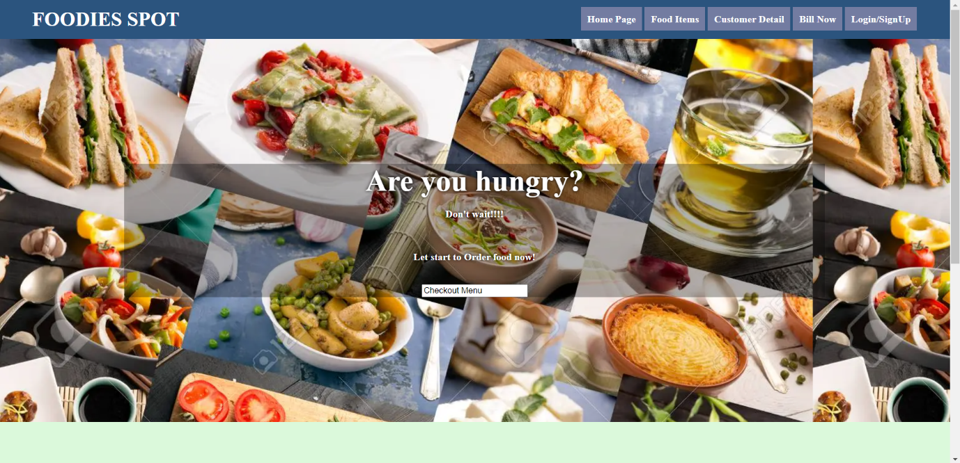

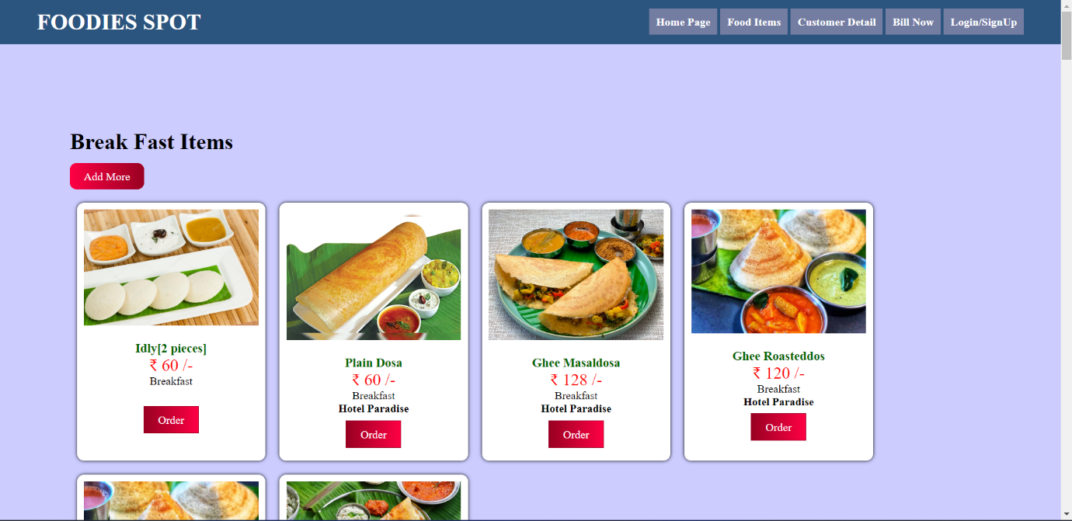

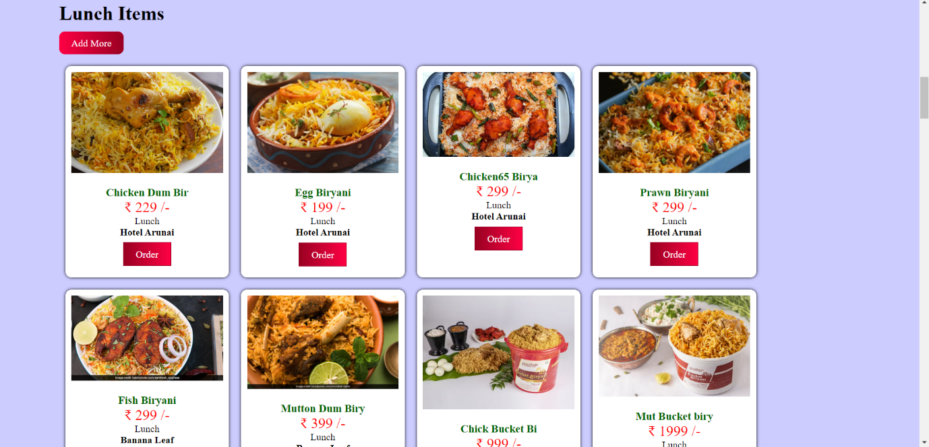

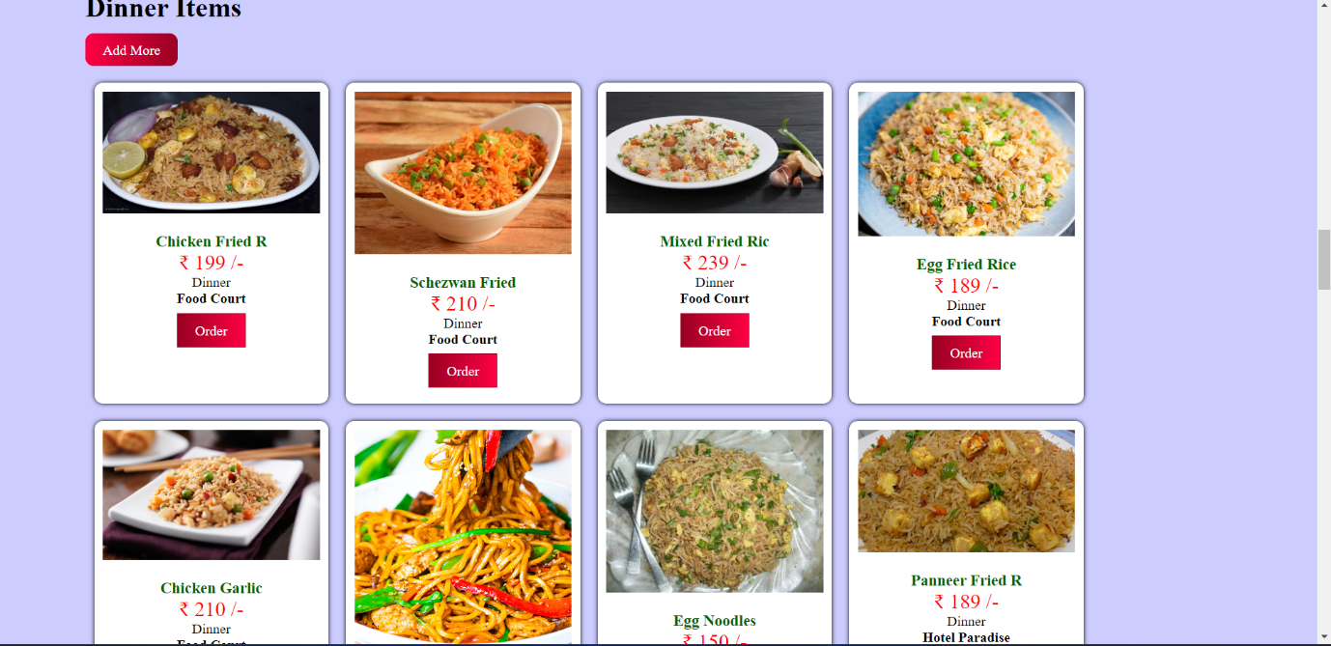

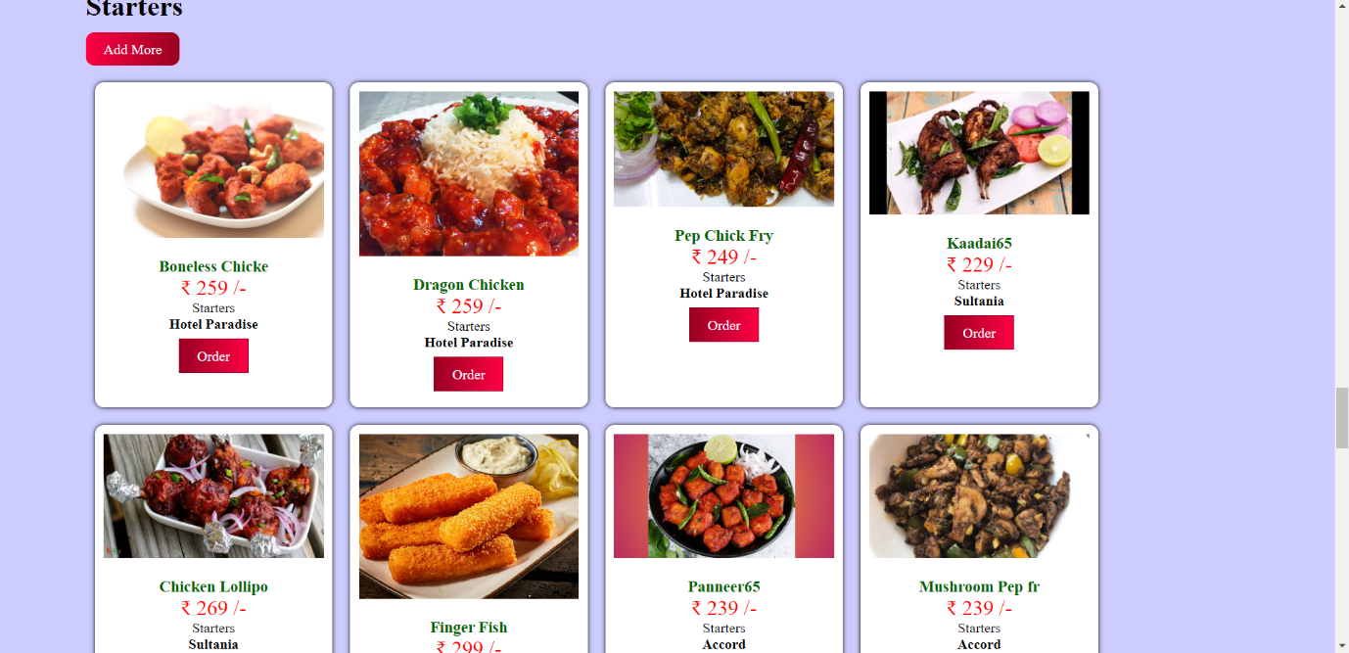

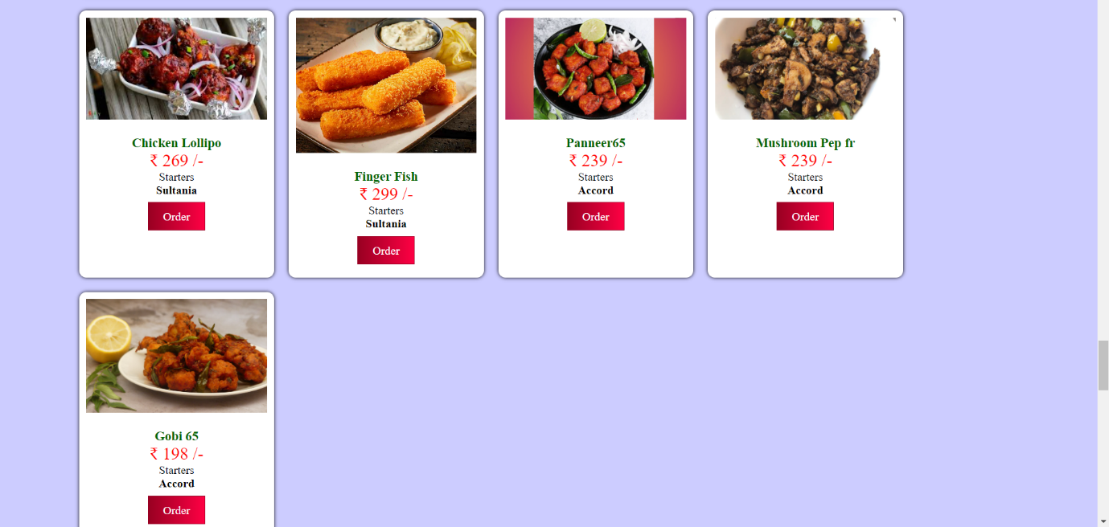

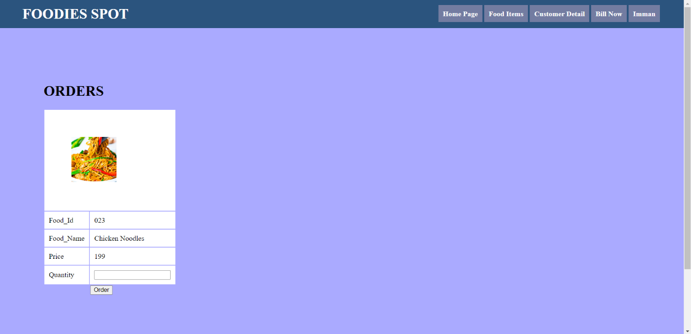

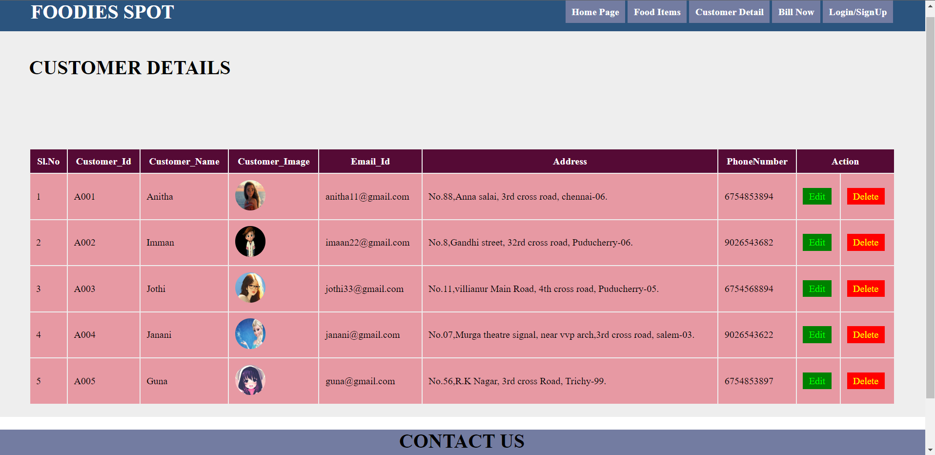

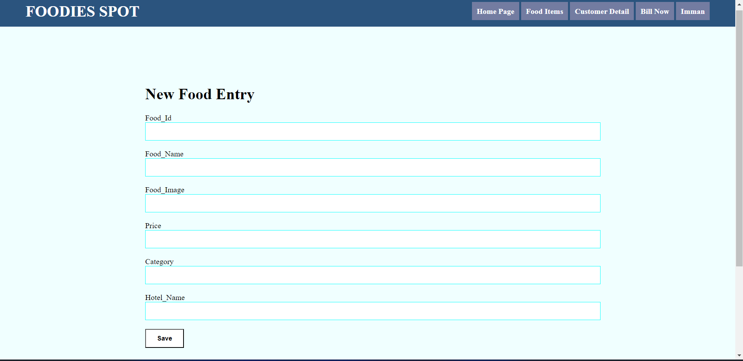

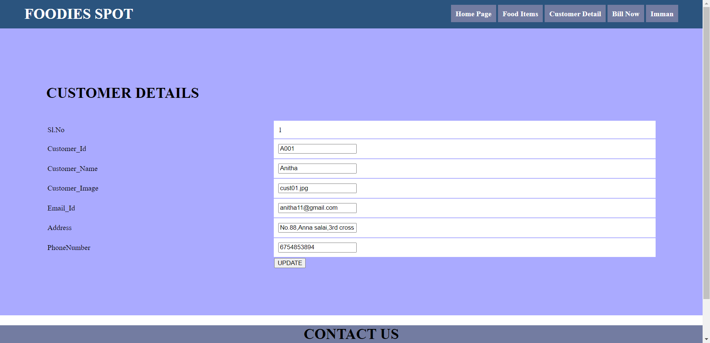

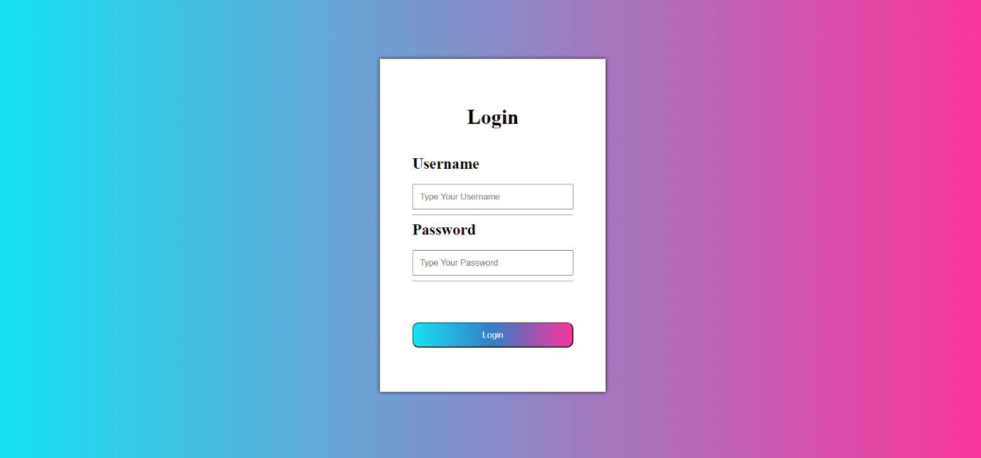

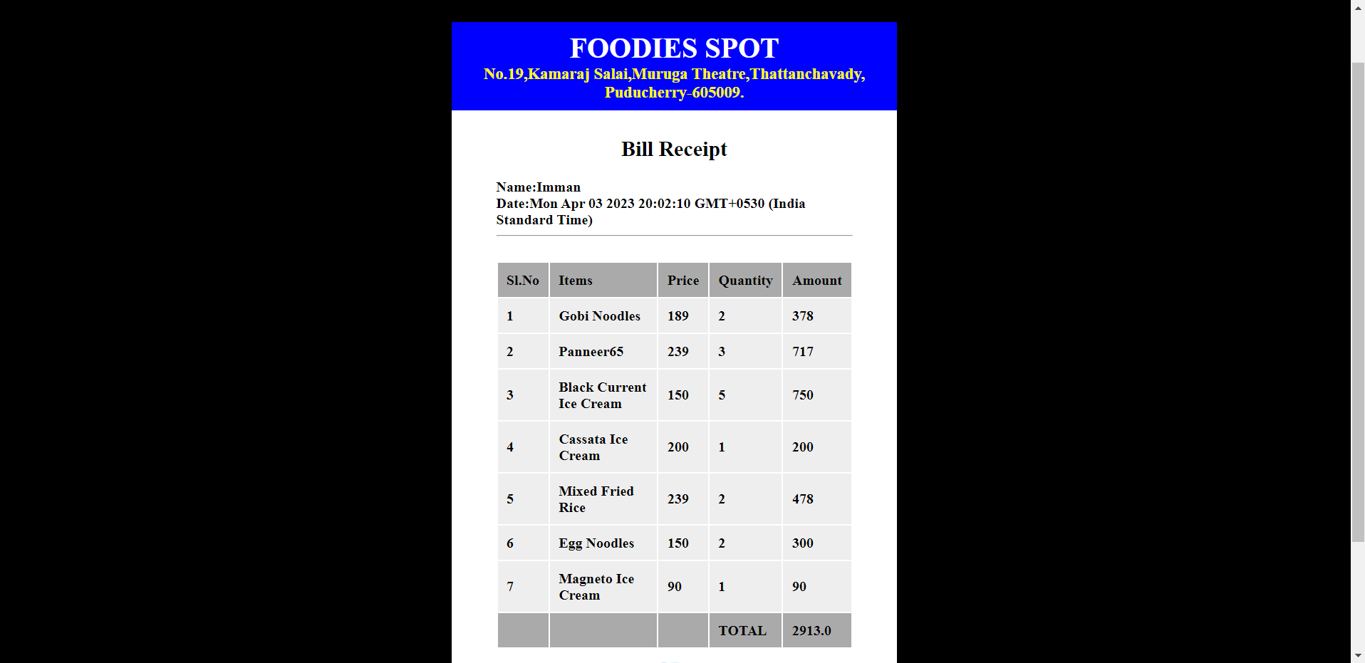

**Source Code**

**Main.py**

import datetime  
from flask import Flask, render_template, request, redirect, url_for, session  
import mysql.connector  
  
con=mysql.connector.connect(user="root", database="foodies")  
app = Flask(__name__)  
app.secret_key="viva"  
@app.route("/")  
def home():  
 session["user"]="no"  
 return render_template("home.html")  
  
  
@app.route("/fooditems")  
def fooditems():  
 cur1=con.cursor()  
 cur1.execute("select * from dishes where Category='Breakfast'")  
 result1=cur1.fetchall()  
  
 cur2 = con.cursor()  
 cur2.execute("select * from dishes where Category='Lunch'")  
 result2 = cur2.fetchall()  
  
 cur3 = con.cursor()  
 cur3.execute("select * from dishes where Category='Dinner'")  
 result3 = cur3.fetchall()  
  
 cur4 = con.cursor()  
 cur4.execute("select * from dishes where Category='Starters'")  
 result4 = cur4.fetchall()  
  
 cur5 = con.cursor()  
 cur5.execute("select * from dishes where Category='Ice Cream'")  
 result5 = cur5.fetchall()  
 return render_template("fooditems.html", data1=result1, data2=result2, data3=result3, data4=result4, data5=result5)  
  
@app.route("/foodentry")  
def foodentry():  
 return render_template("foodentry.html")  
  
@app.route("/dishessave",methods=["POST","GET"])  
def dishessave():  
 if request.method == "POST":  
 a = request.form["Food_Id"]  
 print(a)  
 b = request.form["Food_Name"]  
 print(b)  
 c = request.form["Food_Image"]  
 print(c)  
 d = request.form["Price"]  
 print(d)  
 e = request.form["Category"]  
 print(e)  
 f = request.form["Hotel_Name"]  
 print(f)  
 cur=con.cursor()  
 cur.execute("insert INTO dishes values('"+a+"','"+b+"','"+c+"','"+d+"','"+e+"','"+f+"')")  
 con.commit()  
 cur.close()  
 return redirect(url_for("dishes"))  
  
  
@app.route("/custmerdetail")  
def custmerdetail():  
 cur=con.cursor()  
 cur.execute("select * from customer")  
 result=cur.fetchall()  
 return render_template("custmerdetail.html", data=result)  
  
@app.route("/customeredit")  
def custmer():  
 id = request.args.get("id")  
 cur = con.cursor()  
 cur.execute("select * from customer where Customer_Id='"+id+"'")  
 result = cur.fetchall()  
 return render_template("custmer.html", data=result)  
  
  
  
@app.route("/custmerupdate", methods=["POST","GET"])  
def custmerupdate():  
 if request.method == "POST":  
 a = request.form["cusid"]  
 print(a)  
 b = request.form["cname"]  
 print(b)  
 c = request.form["email"]  
 print(c)  
 d = request.form["add"]  
 print(d)  
 e = request.form["phone"]  
 print(e)  
 f = request.form["custimage"]  
 print(f)  
 cur=con.cursor()  
 cur.execute("update customer set Customer_Name='"+b+"', Email_Id='"+c+"', Address='"+d+"', PhoneNumber='"+e+"', Customer_Image='"+f+"' where Customer_Id='" +a+ "'")  
 con.commit()  
 cur.close()  
 return redirect(url_for("customer"))  
  
@app.route("/customerdelete", methods=["GET","POST"])  
def customerdelete():  
 id=request.args.get("id")  
 cur=con.cursor()  
 cur.execute("delete from customer where Customer_Id='"+id+"'")  
 con.commit()  
 cur.close()  
 return redirect(url_for("customer"))  
  
@app.route("/login")  
def login():  
 return render_template("login.html")  
  
@app.route("/logincheckup", methods=["GET","POST"])  
def logincheckup():  
 if request.method == "POST":  
 a = request.form["username"]  
 b = request.form["password"]  
 cur = con.cursor()  
 cur.execute("select * from customer where Customer_Name='"+a+"' and Customer_Id='"+b+"'")  
 result=cur.fetchone()  
 con.commit()  
 cur.close()  
  
 if result:  
 session["user"]=a  
 session["userid"]=b  
 return render_template("home.html")  
 else:  
 return render_template("login.html")  
  
  
@app.route("/orders")  
def orders():  
 cur = con.cursor()  
 cur.execute("select * from ordersnow where Customer_Id ='"+session["userid"]+"'")  
 result = cur.fetchall()  
 cur.close()  
 cur1 = con.cursor()  
 cur1.execute("select sum(Amount) from ordersnow where Customer_Id ='"+session["userid"]+"'")  
 result1 = cur1.fetchall()  
 cur1.close()  
 return render_template("bill.html", data=result, data1=result1)  
  
  
@app.route("/ordersSave", methods=["POST", "GET"])  
def ordersSave():  
 userid = session["userid"]  
 user = session["user"]  
 fname = request.args.get("fname")  
 prize = request.args.get("prize")  
 qnty = request.form.get("qnty")  
  
 cur = con.cursor()  
 cur.execute("insert into ordersnow values('1','"+ userid +"','"+ user +"','13/03/2023','"+ fname +"','"+ prize +"','2')")  
 con.commit()  
 cur.close()  
 print(qnty)  
 return redirect(url_for("orders"))  
  
  
@app.route("/orderedit")  
def orderedit():  
 id = request.args.get("fid")  
 cur = con.cursor()  
 cur.execute("select * from dishes where Food_Id ='"+id+"'")  
 result = cur.fetchall()  
 return render_template("orderedit.html", data=result)  
  
  
@app.route("/orderupdate", methods=["POST","GET"])  
def orderupdate():  
 if request.method == "POST":  
 a = request.form["ord"]  
 print(a)  
 b = request.form["usname"]  
 print(b)  
 c = request.form["pri"]  
 print(c)  
 d = request.form["qnty"]  
 print(d)  
 e = int(c)*int(d)  
 print(e)  
 cur=con.cursor()  
 cur.execute("Insert into ordersnow Values('"+a+"','"+session["userid"]+"','"+session["user"]+"','"+str(datetime.datetime.now())+"','"+b+"','"+c+"','"+d+"','"+str(e)+"')")  
 con.commit()  
 cur.close()  
 return redirect(url_for("orders"))  
  
@app.route("/footer")  
def footer():  
 return render_template("footer.html")  
  
  
if __name__ == "__main__":  
 app.run()

**home.html**

<!DOCTYPE html>  
<html lang="en">  
<head>  
 <meta charset="UTF-8">  
 <title>HOME PAGE</title>  
 <style>  
 .picdiv  
 {  
 padding:200px;  
 background-image:url("/static/fd.jpg");  
 text-shadow:0 0 5px black;  
 }  
 .pictxt  
 {  
 color:white;  
 font-weight:bold;  
 background-color:rgba(0,0,0,0.3);  
 text-align:center;  
 }  
  
 .hom1  
 {  
 font-weight:bold;  
 font-size:40px;  
 color:black;  
 background-color:#DBF9DB;  
 padding:20px;  
 }  
 .hom2  
 {  
 background-color:#FF007F;  
 width:90px;  
 color:white;  
 border-radius:10px;  
 padding:15px 10px;  
 border:1px solid #902;  
 text-decoration:none;  
 text-align:center;  
 text-weight:bold;  
  
 }  
 .s1  
 {  
 color:#36F57F;  
 }  
 </style>  
</head>  
<body>  
<div>  
 {% include "header.html" %}  
</div>  
<div class="picdiv">  
 <div class="pictxt">  
 <font size="7" color="white"><b>Are you hungry?</b></font><br>  
 <p>Don't wait!!!!</p><br>  
 <p>Let start to Order food now!</p><br>  
 <input type="text" value="Checkout Menu" class="txt">  
 </div>  
</div>  
<div class="hom1">  
 <h1>Welcome {{ session["user"] }}</h1>  
 <p>Pick Your  
 <span class="s1">Own Online <br>Food Orders</span> in  
 <span class="s1">Five minutes</span> or<br> less!</p>  
 <input type="button" value="Order Now" class="hom2">  
</div>  
<div>  
 {% include "footer.html" %}  
</div>  
</body>  
</html>

**Login.html**

<!DOCTYPE html>  
<html lang="en">  
<head>  
 <meta charset="UTF-8">  
 <title>Login</title>  
 <style>  
 body  
 {  
 background-image:linear-gradient(90deg,#16E2F5,#FD349C);  
 }  
 .log  
 {  
  
 width:80px 50px;  
 text-align:center;  
 }  
 .btn  
 {  
 background-image:linear-gradient(90deg,#16E2F5,#357EC7,#FD349C);  
 padding:10px 20px;  
 color:white;  
 width:100%;  
 border-radius:10px;  
 border1px solid #902;  
 text-decoration:none;  
 }  
 .btn:hover  
 {  
 background-color:cyan;  
 background-image:linear-gradient(90deg,#357EC7,#16E2F5);  
 }  
 .box2  
 {  
 padding:50px;  
 background-color:white;  
 width:350px;  
 box-shadow:0 0 5px black;  
 text-align:left;  
 margin:100px auto;  
 box-sizing:border-box;  
 }  
 .txtbox  
 {  
 width:100%;  
 padding:10px;  
 box-sizing:border-box;  
 }  
 </style>  
</head>  
<body>  
<div class="log">  
 <div class="box2">  
 <form name="form" action="/logincheckup" method="POST">  
 <center><h1>Login</h1></center><br>  
 <font size="5" text-align="left"><b>Username</b></font><br><br>  
 <input type="text" name="username" placeholder="Type Your Username" class="txtbox">  
 <hr>  
 <font size="5"><b>Password</b></font><br><br>  
 <input type="password" name="password" placeholder="Type Your Password" class="txtbox">  
 <hr><br><br><br>  
 <input type="Submit" value="Login" class="btn"><br><br>  
 </form>  
 </div>  
</div>  
  
</body>  
</html>

**fooditems.html**

<!DOCTYPE html>  
<html lang="en">  
<head>  
 <meta charset="UTF-8">  
 <title>fooditems</title>  
 <style>  
 .foodies1  
 {  
 padding:100px;  
 background-color:#ccf;  
 }  
 .ety  
 {  
 background-color:red;  
 background-image:linear-gradient(90deg,#f04,#902);  
 padding:10px 20px;  
 color:white;  
 border-radius:10px;  
 border1px solid #902;  
 text-decoration:none;  
 }  
 .ety:hover  
 {  
 background-color:blue;  
 background-image:linear-gradient(90deg,#902,#f04);  
 }  
 .od11  
 {  
 background-color:red;  
 color:white;  
 text-weight:bold;  
 text-decoration:none;  
 border:1px solid #902;  
 padding:10px 20px;  
 background-image:linear-gradient(90deg,#902,#f04);  
 border_radius:10px;  
 }  
 .box  
 {  
 padding:10px;  
 background-color:#fff;  
 width:250px;  
 margin:10px;  
 box-shadow:0 0 5px black;  
 text-align:center;  
 border-radius:10px;  
 }  
 .flexdivision  
 {  
 display:flex;  
 flex-wrap:wrap;  
 }  
 .numhigh  
 {  
 padding:70px;  
 background-color:white;  
 width:50px;  
 height:50px;  
 border-radius:50%  
 text-align:centre;  
 font-size:30px;  
 color:green;  
 }  
 </style>  
</head>  
<body>  
<div>  
 {% include "header.html" %}  
</div>  
  
<div class="foodies1">  
 <h1>Break Fast Items</h1>  
 <a class="ety" href="/foodentry">Add More</a><br><br>  
<div class="flexdivision">  
 {% for row in data1 %}  
 <div class="box">  
 <img src="static/{{ row[2] }}" width="100%"><br><br>  
 <font color="darkgreen" size="4"><b>{{ row[1] }}</b></font> <br>  
 <font color="red" size="5">&#8377 {{ row[3] }} /-</font><br>  
 {{ row[4] }}<br>  
 <b>{{ row[5] }}</b><br><br>  
  
  
 <a class="od11" href="/orderedit?fid={{ row[0] }} ">Order</a><br><br>  
 </div>  
 {% endfor %}  
</div>  
</div>  
  
<div class="foodies1">  
 <h1>Lunch Items</h1>  
 <a class="ety" href="/foodentry">Add More</a><br><br>  
<div class="flexdivision">  
 {% for row in data2 %}  
 <div class="box">  
 <img src="static/{{ row[2] }}" width="100%"><br><br>  
 <font color="darkgreen" size="4"><b>{{ row[1] }}</b></font> <br>  
 <font color="red" size="5">&#8377 {{ row[3] }} /-</font><br>  
 {{ row[4] }}<br>  
 <b>{{ row[5] }}</b><br><br>  
  
 <a class="od11" href="/orderedit?fid={{ row[0] }} ">Order</a><br><br>  
 </div>  
 {% endfor %}  
</div>  
</div>  
  
<div class="foodies1">  
 <h1>Dinner Items</h1>  
 <a class="ety" href="/foodentry">Add More</a><br><br>  
<div class="flexdivision">  
 {% for row in data3 %}  
 <div class="box">  
 <img src="static/{{ row[2] }}" width="100%"><br><br>  
 <font color="darkgreen" size="4"><b>{{ row[1] }}</b></font> <br>  
 <font color="red" size="5">&#8377 {{ row[3] }} /-</font><br>  
 {{ row[4] }}<br>  
 <b>{{ row[5] }}</b><br><br>  
  
 <a class="od11" href="/orderedit?fid={{ row[0] }} ">Order</a><br><br>  
 </div>  
 {% endfor %}  
</div>  
</div>  
  
  
<div class="foodies1">  
 <h1>Starters</h1>  
 <a class="ety" href="/foodentry">Add More</a><br><br>  
<div class="flexdivision">  
 {% for row in data4 %}  
 <div class="box">  
 <img src="static/{{ row[2] }}" width="100%"><br><br>  
 <font color="darkgreen" size="4"><b>{{ row[1] }}</b></font> <br>  
 <font color="red" size="5">&#8377 {{ row[3] }} /-</font><br>  
 {{ row[4] }}<br>  
 <b>{{ row[5] }}</b><br><br>  
  
 <a class="od11" href="/orderedit?fid={{ row[0] }} ">Order</a><br><br>  
 </div>  
 {% endfor %}  
</div>  
</div>  
  
  
<div class="foodies1">  
 <h1>Ice Creams</h1>  
 <a class="ety" href="/foodentry">Add More</a><br><br>  
<div class="flexdivision">  
 {% for row in data5 %}  
 <div class="box">  
 <img src="static/{{ row[2] }}" width="100%"><br><br>  
 <font color="darkgreen" size="4"><b>{{ row[1] }}</b></font> <br>  
 <font color="red" size="5">&#8377 {{ row[3] }} /-</font><br>  
 {{ row[4] }}<br>  
 <b>{{ row[5] }}</b><br><br>  
  
 <a class="od11" href="/orderedit?fid={{ row[0] }} ">Order</a><br><br>  
 </div>  
 {% endfor %}  
</div>  
</div>  
  
  
<div>  
 {% include "footer.html" %}  
</div>  
</body>  
</html>

**foodentry.html (Add more)**

<!DOCTYPE html>  
<html lang="en">  
<head>  
 <meta charset="UTF-8">  
 <title>entry</title>  
 <style>  
 .entry1  
 {  
 background-color:#F0FFFF;  
 padding:100px 300px;  
 }  
 .txt  
 {  
 padding:10px;  
 width:100%;  
 border:1px solid #00ffff;  
  
 }  
 .btn  
 {  
 color:white;  
 background-color:violet;  
 padding:10px;  
 width:80px;  
 font-weight:bold;  
 }  
 </style>  
  
</head>  
<body>  
<div>  
 {% include "header.html" %}  
</div>  
<div class="entry1">  
 <h1>New Food Entry</h1>  
 <form name="form" action="/dishessave" method="post">  
 Food_Id<br>  
 <input type="text" class="txt" name="Food_Id"><br><br>  
 Food_Name<br>  
 <input type="text" class="txt" name="Food_Name"><br><br>  
 Food_Image  
 <input type="text" class="txt" name="Food_Image"><br><br>  
 Price<br>  
 <input type="text" class="txt" name="Price"><br><br>  
 Category<br>  
 <input type="text" class="txt" name="Category"><br><br>  
 Hotel_Name<br>  
 <input type="text" class="txt" name="Hotel_Name"><br><br>  
 <input type="Submit" value="Save" class="btn" name="Save"><br>  
 </form>  
</div>  
<div>  
 {% include "footer.html" %}  
</div>  
</body>  
</html>

**orderedit.html**

<!DOCTYPE html>  
<html lang="en">  
<head>  
 <meta charset="UTF-8">  
 <title>orderupdate</title>  
 <style>  
 .orupt  
 {  
 padding:100px;  
 background-color:#aaf;  
 }  
 .ts  
 {  
 padding:10px;  
 background-color:#fff;  
 color:black;  
 }  
 .photo  
 {  
  
 width:100px;  
 height:100px;  
 padding:50px;  
 }  
  
 </style>  
</head>  
<body>  
<div>  
 {% include "header.html" %}  
</div>  
<div class="orupt">  
 <h1>ORDERS</h1>  
 <form name="form" action="/orderupdate" method="POST">  
 <table border="0">  
  
 {% for row in data %}  
  
 <tr><td class="ts" colspan="2"><img class="photo" src="static/{{ row[2] }}" width="100%"></td></tr>  
 <tr><td class="ts">Food_Id</td><td class="ts"> <input type="hidden" name="ord" value="{{ row[0] }}">{{ row[0] }} </td></tr>  
 <tr><td class="ts">Food_Name</td><td class="ts"><input type="hidden" name="usname" value="{{ row[1] }}">{{ row[1] }}</td></tr>  
 <tr><td class="ts">Price</td><td class="ts"><input type="hidden" name="pri" value="{{ row[3] }}">{{ row[3] }} </td></tr>  
 <tr><td class="ts">Quantity</td><td class="ts"><input type="text" value="" name="qnty"></td></tr>  
  
  
 <tr><td></td><td><input type="Submit" value="Order"></td></tr>  
 {% endfor %}  
  
  
 </table>  
 </form>  
</div>  
<div>  
 {% include "footer.html" %}  
</div>  
</body>  
</html>

**custmerdetail.html**

<!DOCTYPE html>  
<html lang="en">  
<head>  
 <meta charset="UTF-8">  
 <title>customer Detail</title>  
 <style>  
 .customer1  
 {  
 padding:20px 50px;  
 background-color:#eee;  
 }  
  
 .ths  
 {  
 padding:10px;  
 background-color:#550A35;  
 color:white;  
 }  
 .tds  
 {  
 padding:10px;  
 background-color:#E799A3;  
 color:black;  
 }  
 .tdse  
 {  
 padding:5px 10px;  
 background-color:green;  
 color:lime;  
 text-decoration:none;  
 }  
 .tdsd  
 {  
 padding:5px 10px;  
 background-color:red;  
 color:yellow;  
 text-decoration:none;  
 }  
 .photo  
 {  
 border-radius:50%;  
 width:50px;  
 height:50px;  
 }  
 </style>  
</head>  
<body>  
<div>  
 {% include "header.html" %}  
</div>  
<div class="customer1">  
 <h1>CUSTOMER DETAILS</h1>  
 <table border="0" width="100%">  
 <tr>  
 <th class="ths">Sl.No</th>  
 <th class="ths">Customer_Id</th>  
 <th class="ths">Customer_Name</th>  
 <th class="ths">Customer_Image</th>  
 <th class="ths">Email_Id</th>  
 <th class="ths">Address</th>  
 <th class="ths">PhoneNumber</th>  
 <th class="ths" colspan="2">Action</th>  
  
 </tr>  
 {% for row in data %}  
 <tr>  
 <td class="tds">{{ loop.index }}</td>  
 <td class="tds">{{ row[0] }}</td>  
 <td class="tds">{{ row[1] }}</td>  
 <td class="tds"><img class="photo" src="static/{{ row[5] }}" width="100%"></td>  
 <td class="tds">{{ row[2] }}</td>  
 <td class="tds">{{ row[3] }}</td>  
 <td class="tds">{{ row[4] }}</td><br>  
 <td class="tds"><a class="tdse" href="/customeredit?id={{ row[0] }}">Edit</a></td>  
 <td class="tds"><a class="tdsd" href="/customerdelete?id={{ row[0] }}">Delete</a></td>  
  
 </tr>  
 {% endfor %}  
 </table>  
</div>  
<div>  
 {% include "footer.html" %}  
</div>  
  
</body>  
</html>

**customer.html**

<!DOCTYPE html>  
<html lang="en">  
<head>  
 <meta charset="UTF-8">  
 <title>edit</title>  
 <style>  
 .cust11  
 {  
 padding:100px;  
 background-color:#aaf;  
 }  
 .ety  
 {  
 background-color:blue;  
 background-image:linear-gradient(90deg,#f04,#902);  
 padding:10px 20px;  
 color:white;  
 border-radius:10px;  
 border:1px solid #902;  
 text-decoration:none;  
 }  
 .ety:hover  
 {  
 background-color:blue;  
 background-image:linear-gradient(90deg,#902,#f04);  
 }  
 .ths  
 {  
 padding:10px;  
 background-color:#00f;  
 color:white;  
 }  
 .tds  
 {  
 padding:10px;  
 background-color:#fff;  
 color:black;  
 }  
 .tdse  
 {  
 padding:5px 10px;  
 background-color:green;  
 color:lime;  
 text-decoration:none;  
 }  
 .tdsd  
 {  
 padding:5px 10px;  
 background-color:red;  
 color:yellow;  
 text-decoration:none;  
 }  
 .box  
 {  
 padding:10px;  
 background-color:#fff;  
 width:250px;  
 margin:10px;  
 box-shadow:0 0 5px black;  
 }  
 .flexdivision  
 {  
 display:flex;  
 flex-wrap:wrap;  
 }  
 .numhigh  
 {  
 padding:10px;  
 background-color:#f00;  
 width:50px;  
 height:50px;  
 border-radius:50%;  
 text-align:center;  
 font-size:30px;  
 color:yellow;  
 }  
  
 </style>  
</head>  
<body>  
<div>  
 {% include "header.html" %}  
</div>  
  
<div class="cust11">  
 <h1>CUSTOMER DETAILS</h1>  
 <form name="form" action="/custmerupdate" method="POST">  
 <table border="0" width="100%">  
  
 {% for row in data %}  
  
 <tr><td>Sl.No</td><td class="tds" name="sl">{{ loop.index }}</td></tr>  
 <tr><td>Customer_Id</td><td class="tds"><input type="text" value="{{ row[0] }}" class="txtx" name="custid"></td></tr>  
 <tr><td>Customer_Name</td><td class="tds"><input type="text" value="{{ row[1] }}" class="txtx" name="cname"></td></tr>  
 <tr><td>Customer_Image</td><td class="tds"><input type="text" value="{{ row[5] }}" class="txtx" name="custimage"></td></tr>  
 <tr><td>Email_Id</td><td class="tds"><input type="text" value="{{ row[2] }}" class="txtx" name="email"></td></tr>  
 <tr><td>Address</td><td class="tds"><input type="text" value="{{ row[3] }}" class="txtx" name="add"></td></tr>  
 <tr><td>PhoneNumber</td><td class="tds"><input type="text" value="{{ row[4] }}" class="txtx" name="phone"></td></tr><br>  
  
 <tr><td></td><td><input type="Submit" value="UPDATE"></td></tr>  
 {% endfor %}  
 </table>  
 </form>  
</div>  
<div>  
 {% include "footer.html" %}  
</div>  
  
</body>  
</html>

**customeredit.html**

<!DOCTYPE html>  
<html lang="en">  
<head>  
 <meta charset="UTF-8">  
 <title>edit</title>  
 <style>  
 .cust11  
 {  
 padding:100px;  
 background-color:#aaf;  
 }  
 .ety  
 {  
 background-color:blue;  
 background-image:linear-gradient(90deg,#f04,#902);  
 padding:10px 20px;  
 color:white;  
 border-radius:10px;  
 border:1px solid #902;  
 text-decoration:none;  
 }  
 .ety:hover  
 {  
 background-color:blue;  
 background-image:linear-gradient(90deg,#902,#f04);  
 }  
 .ths  
 {  
 padding:10px;  
 background-color:#00f;  
 color:white;  
 }  
 .tds  
 {  
 padding:10px;  
 background-color:#fff;  
 color:black;  
 }  
 .tdse  
 {  
 padding:5px 10px;  
 background-color:green;  
 color:lime;  
 text-decoration:none;  
 }  
 .tdsd  
 {  
 padding:5px 10px;  
 background-color:red;  
 color:yellow;  
 text-decoration:none;  
 }  
 .box  
 {  
 padding:10px;  
 background-color:#fff;  
 width:250px;  
 margin:10px;  
 box-shadow:0 0 5px black;  
 }  
 .flexdivision  
 {  
 display:flex;  
 flex-wrap:wrap;  
 }  
 .numhigh  
 {  
 padding:10px;  
 background-color:#f00;  
 width:50px;  
 height:50px;  
 border-radius:50%;  
 text-align:center;  
 font-size:30px;  
 color:yellow;  
 }  
  
 </style>  
</head>  
<body>  
<div>  
 {% include "header.html" %}  
</div>  
  
<div class="cust11">  
 <h1>CUSTOMER DETAILS</h1>  
 <form name="form" action="/customerupdate" method="POST">  
 <table border="0" width="100%">  
  
 {% for row in data %}  
  
 <tr><td>Sl.No</td><td class="tds" name="sl">{{ loop.index }}</td></tr>  
 <tr><td>Customer_Id</td><td class="tds"><input type="text" value="{{ row[0] }}" class="txtx" name="custid"></td></tr>  
 <tr><td>Customer_Name<td class="tds"><input type="text" value="{{ row[1] }}" class="txtx" name="cname"></td></tr>  
 <tr><td>Customer_Image<td class="tds"><input type="text" value="{{ row[5] }}" class="txtx" name="custimage"></td></tr>  
 <tr><td>Email_Id<td class="tds"><input type="text" value="{{ row[2] }}" class="txtx" name="email"></td></tr>  
 <tr><td>Address<td class="tds"><input type="text" value="{{ row[3] }}" class="txtx" name="add"></td></tr>  
 <tr><td>PhoneNumber<td class="tds"><input type="text" value="{{ row[4] }}" class="txtx" name="phone"></td></tr><br>  
  
 <tr><td></td><td><input type="Submit" value="UPDATE"></td></tr>  
 {% endfor %}  
 </table>  
 </form>  
</div>  
<div>  
 {% include "footer.html" %}  
</div>  
  
</body>  
</html>

**bill.html**

<!DOCTYPE html>  
<html lang="en">  
<head>  
 <meta charset="UTF-8">  
 <title>order</title>  
 <script type="text/javascript">  
  
 var dt=new Date();  
 window.onload = function()  
 {  
 document.getElementById("datespan").innerHTML=""+dt;  
 }  
 </script>  
 <style>  
 body  
 {  
 background-color:black;  
 text-align:center;  
 }  
 .bill  
 {  
  
 width:80px 50px;  
 text-align:center;  
 font-weight:bold;  
 color:black;  
  
 }  
 .ths  
 {  
 background-color:#aaa;  
 color:black;  
 padding:10px;  
 font-weight:bold;  
 }  
 .tds  
 {  
 background-color:#eee;  
 color:black;  
 padding:10px;  
 }  
 .box1  
 {  
 background-color:white;  
 width:500px;  
 box-shadow:0 0 5px black;  
 text-align:left;  
 margin:100px auto;  
 }  
 .photo1  
 {  
 border-radius:50%;  
 width:50px;  
 height:50px;  
 }  
 .head01 {  
 background-color:blue;  
 padding:10px;  
 color: white;  
 font-weight:bold;  
 }  
 .odr1  
 {  
 background-color:white;  
 padding:10px 50px;  
 }  
 .box2  
 {  
 padding:10px 50px;  
 }  
 </style>  
</head>  
<body>  
<div class="bill">  
 <div class="box1">  
 <div class="head01">  
 <center>  
 <font color="white" size="6">FOODIES SPOT</font><br>  
 <font color="yellow" size="4">No.19,Kamaraj Salai,Muruga Theatre,Thattanchavady,<br>Puducherry-605009.</font></center>  
 </div>  
 <div class="box2">  
 <center><h2><b>Bill Receipt</b></h2></center>  
 Name:{{ session["user"] }}<br>  
 Date:<span id="datespan">sample</span>  
 <hr>  
  
 </div>  
 <div class="odr1">  
  
 <table border="0" width="100%">  
 <tr>  
 <th class="ths">Sl.No</th>  
 <th class="ths">Items</th>  
 <th class="ths">Price</th>  
 <th class="ths">Quantity</th>  
 <th class="ths">Amount</th>  
  
 </tr>  
  
 {% for row in data %}  
 <tr>  
 <td class="tds">{{ loop.index }}</td>  
 <td class="tds">{{ row[4] }}</td>  
 <td class="tds">{{ row[5] }}</td>  
 <td class="tds">{{ row[6] }}</td>  
 <td class="tds">{{ row[7] }}</td>  
  
  
 </tr>  
  
 {% endfor %}  
 <tr>  
  
 <th class="ths"></th>  
 <th class="ths"></th>  
 <th class="ths"></th>  
 <th class="ths">TOTAL</th>  
 {% for row1 in data1 %}  
 <th class="ths">{{ row1[0] }}</th>  
 {% endfor %}  
 </tr>  
 </table>  
 </div>  
 <center>  
 <img class="photo1" src="static/ft.jpg"><br>  
 <font color="blue" size="2">Hope you enjoy your dining experience!</font><br>  
 </center>  
 </div>  
</div>  
</body>  
</html>

**header.html**

<!DOCTYPE html>  
<html lang="en">  
<head>  
 <meta charset="UTF-8">  
 <title>HEADER</title>  
 <style>  
  
  
 body  
 {  
 margin:0;  
 padding:0;  
 }  
 .head1  
 {  
 background-color:#2B547E;  
 padding:10px 50px;  
 }  
 .menu  
 {  
  
 color:white;  
 font-weight:bold;  
 padding:10px;  
 background-color:#737CA1;  
 text-decoration:none;  
 }  
 .menu:hover  
 {  
 color:violet;  
 background-color:#550A35;  
 }  
 </style>  
</head>  
<body>  
  
<div class="head1">  
 <table width="100%">  
 <tr>  
 <td align="left"><font color="white" size="6"><b>FOODIES SPOT</b></font></td>  
 <td align="right">  
 <a href="/home" class="menu">Home Page</a>  
 <a href="/fooditems" class="menu">Food Items</a>  
 <a href="/custmerdetail" class="menu">Customer Detail</a>  
 <a href="/orders" class="menu">Bill Now</a>  
 {% if session["user"] == 'no' %}  
 <a href="/login" class="menu">Login/SignUp</a>  
 {% else %}  
 <a href="#" class="menu">{{ session["user"] }}</a>  
 {% endif %}  
 </tr>  
</table>  
</div>  
  
</body>  
</html>

**footer.html**

<!DOCTYPE html>  
<html lang="en">  
<head>  
 <meta charset="UTF-8">  
 <title>footer</title>  
 <style>  
 .cont  
 {  
 background-color:#737CA1;  
 color:while;  
 text-align:center;  
 }  
 .btn  
 {  
 background-color:white;  
 color:black;  
 font-weight:bold;  
 text-align:center;  
 }  
 </style>  
</head>  
<body>  
<div class="cont">  
  
 <h1><b>CONTACT US</b></h1>  
 <p>Its's Food Lovers like you who inspire us to do what we do. Your comments,ideas and question pushes to <br>go that extra mile, everytime. So drop us a line!!</p>  
 <input type="button" value="Get in Touch" class="btn">  
  
</div>  
  
</body>  
</html>

**REFERENCE**

1. <https://www.foodiv.com/?utm_source=googleadsecond&utm_medium=paid_search&utm_campaign=searchsecond&gclid=Cj0KCQjwxYOiBhC9ARIsANiEIfbwtKE-BLb-LHdqVggKqXEZ4CpqPlT9SKddghp7s0DJlGIuaYX6TscaAu3MEALw_wcB>
2. <https://www.behance.net/search/projects?search=Food+Ordering+Website&sort=recommended&time=month>